Standard Subsystems Library (SSL)
Print
The Print subsystem is designed to create print forms of objects based on table templates (MXL format) and office document templates in Office Open XML (docx) format.
The subsystem provides a visual editor for table templates of print forms and Office Open XML (DOCX) templates, thanks to which a user can edit the template built into the program and the print form will be built taking into account its changes. The Print subsystem also includes tools for placing print commands on forms in the "Print" submenu, a preview of print forms and various service capabilities for saving print forms to files, sending by e-mail and creating QR code images. In addition, there is a program interface for creating print forms based on a template built into the configuration.
In simple terms, the Print subsystem provides tools for easy development and customization of print forms, as well as for convenient work with print forms in the Enterprise mode (you can combine print forms into a set, save a separate print form or set into one or several files, send by mail, and other functions). The form also has functions such as automatic calculation of a function in selected numeric cells, for example, calculating the sum:
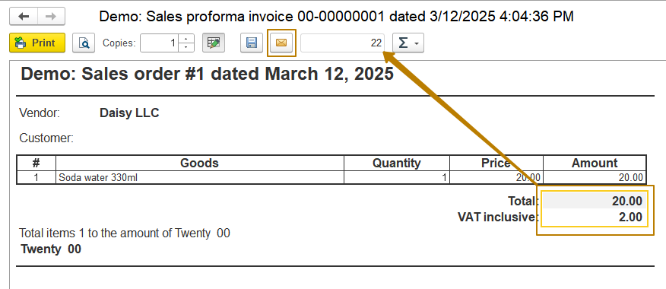
In the lesson on print forms, we created a print command for the document "Sales invoice", which was displayed in the object’s list form and the document form. But this is a fairly simple case, in practice it happens that more than a dozen print forms are connected to a document, then it is better to display them inside the Print submenu, since they will not fit on the command panel and will visually weigh down the interface. But that's not all - the display of some of them may depend on some conditions, for example, on a functional option or on the value of a document attribute. Thus, when the number of printed forms increases, adding them to the configuration can lead to an increase in the time for developing each.
If the Print subsystem is present in the configuration, the developer's task is to connect the object to the subsystem, which must be done once and add print commands using code (without creating the metadata objects of type Command), as well as adding handlers for these commands.
Let's consider these processes using an example.
Task
In the SSL demo configuration there is a document "Demo: Goods receipt", which does not have print commands. Our task will be to connect it to the Print subsystem, and also create 2 print commands: "Goods receipt" and "Receipt at warehouse". The print form "Receipt at warehouse" should be available only for certain warehouses, which we will define later.
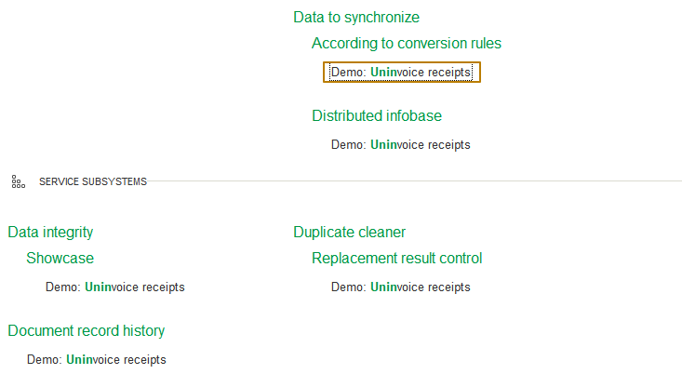
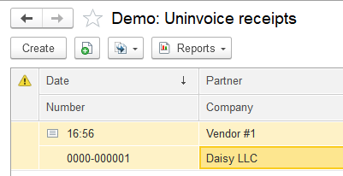
First of all, it is necessary to specify the metadata object connected to the Print subsystem in the PrintManagementOverridable.OnDefinePrintSettings() procedure:
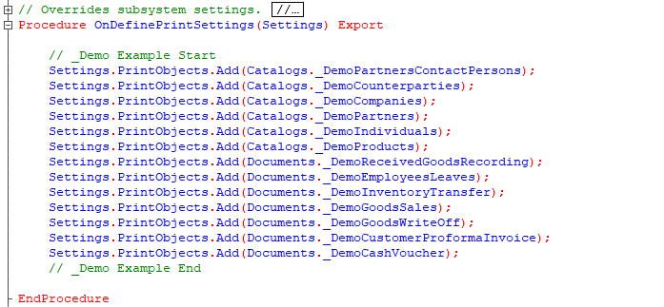
To do this, you need to enable the ability to change for the PrintManagementOverridable common module, after which you should add the metadata object that you want to connect to the subsystem to the PrintObjects array of the Settings property in this procedure:
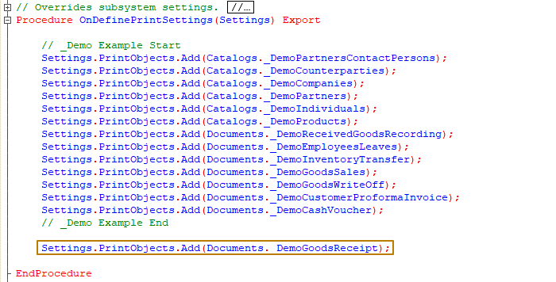
Next, you need to add the AddPrintCommands(PrintCommands) export procedure to the manager module of an object, inside which you should add lines for print commands to the PrintCommands value table. It is recommended to place the code intended for connecting to the subsystem inside service comments indicating the subsystem name. For the Print subsystem, comments look like this:
// StandardSubsystems.Print
…
// End StandardSubsystems.Print
If the module does not yet have such comments, you can add them yourself. For example, in the "Demo: Sales proforma invoice" document manager module, all the code for working with printing is placed between such comments:
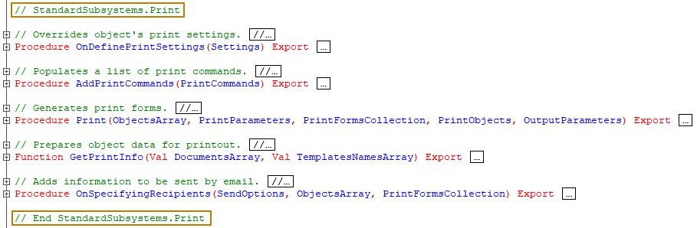
To make changes to the "Demo: Goods receipt" document manager module, you need to enable the ability to change it in the support settings.
First, I'll add one print command and immediately try to check the command display for the object in Enterprise mode:
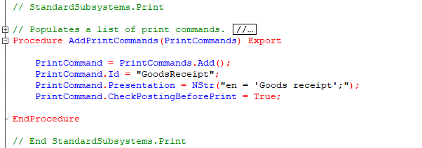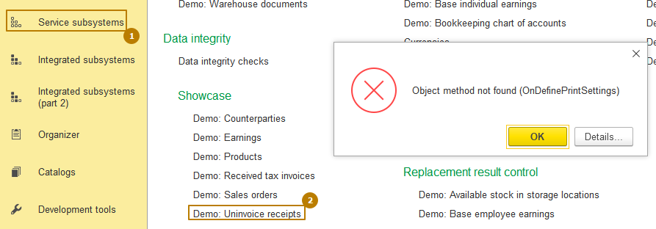
When I try to open the document list form, I get an error that indicates the absence of the object method OnDefiningPrintSettings(Settings). This method should also be located in the object manager module and you can fill in the properties of the Settings structure in it. In general, it is best to follow the documentation for the SSL to figure out how to use certain library mechanisms. But if for some reason there are problems with access to the documentation, you can try to figure it out yourself. For example, I can find the OnDefiningPrintSettings procedure in the manager module of an object that definitely has print forms, such as the "Demo: Sales proforma invoice" document.
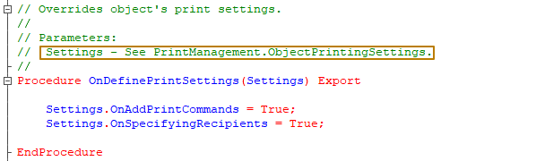 In the description of this procedure, I see that the description of the Settings parameter can be found in the description of the PrintManagement.ObjectPrintingSettings function. I go to the PrintManagement module, find this function using the list of procedures and functions of the module:
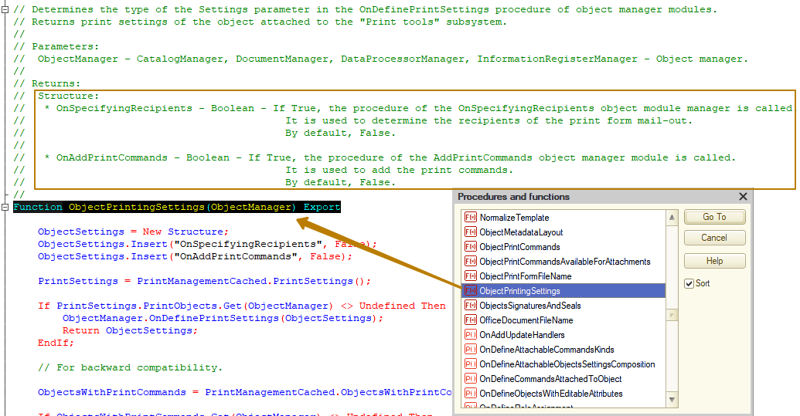
I see that to add print commands, I must assign the value True to the OnAddPrintCommands property
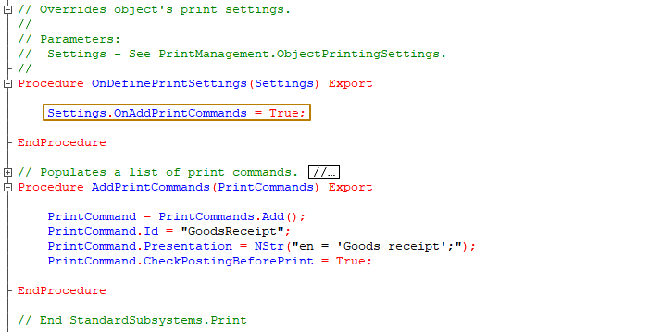

After that, I update the configuration and check the print commands again, this time the command appeared on the form command bar:
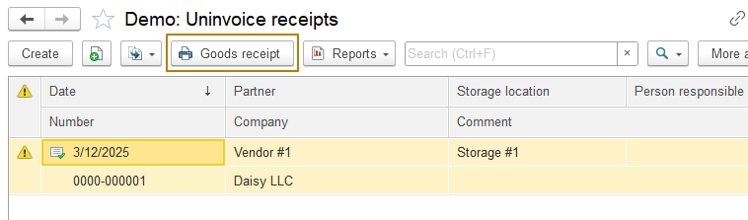
Let me immediately add the second command to check how the subsystem will handle this situation:
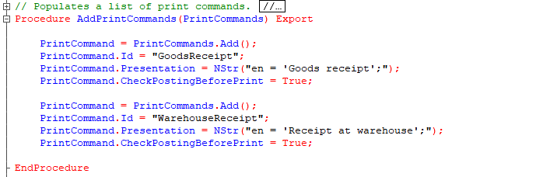
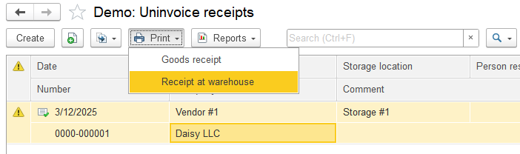
We see that now instead of a single print button there is a "Print" submenu, in which the print commands are located.
Let's figure out how to manage their position in the submenu, because some print forms can be used more often than others and then users will want them to be located higher in the list.
For this purpose, the command table has an "Order" column with the Number type, in which you should specify the priority of the print form order from 1 to 100. The default value is 50. Sorting is performed by the value of this order + presentation, that is, if I now change the order of adding lines to the command table, in the Enterprise mode their order in the submenu should remain the same. Let's check:
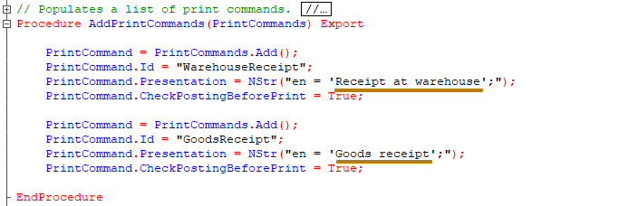
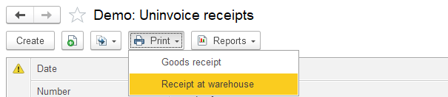
Now I'll add an order for one of the commands to move it up the list:
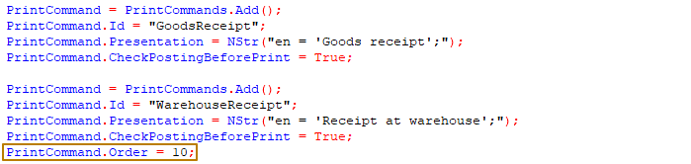
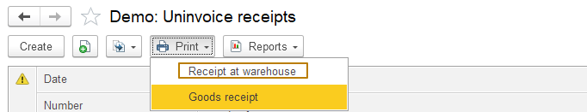
So, changing the order helped - the command with the order 10 moved up above the command with an unspecified order.
As I said earlier, sometimes it is necessary to limit the display of print commands depending on the state of the functional options or the values of the attributes of the object itself (the owner of the print command). To set such restrictions, there are 2 columns in the command table:
1) "FunctionalOptions" of the "String" type, in which you can list the functional options, separated by commas, that affect the display of the command
2) "VisibilityConditions" of the Array type, to which you should add conditions by calling the PrintManagement.AddCommandVisibilityCondition method. The conditions themselves consist of 3 parts: the name of the object attribute, the value with which to compare, the comparison condition.
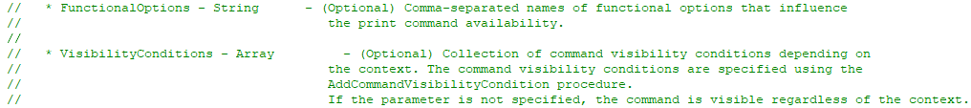
Let's add a visibility condition for one of our commands. For example, I want the "Receipt at warehouse" print command to be displayed only for one specific warehouse, then my task is to get a reference to this warehouse, and then create a visibility condition by calling the PrintManagement.AddCommandVisibilityCondition method:
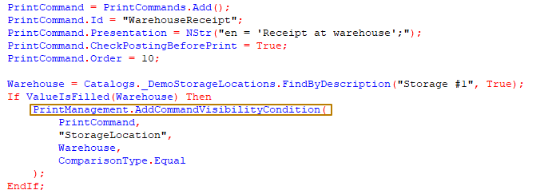
Note: Of course, searching for a warehouse by description is not the best solution from the point of view of the software product, because the warehouse can be renamed, and in another database such a warehouse may never have existed, but in this case I am simply demonstrating the use of a certain mechanism.
I switch to Enterprise mode, create a document with another warehouse and check the print commands for each of the documents. The document with the warehouse from the visibility condition has two print commands available, while the document with another warehouse has only one, which means the visibility condition works.
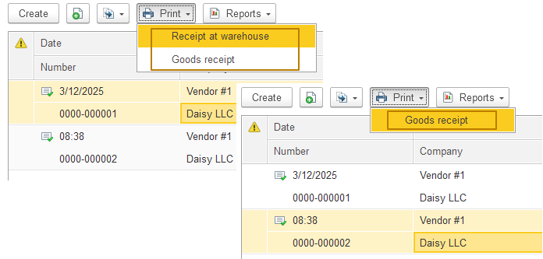
For functional options, everything is quite obvious, I don't see the point in examining this area in detail. For example, if there is a functional option "UseMultipleWarehouses" in the configuration, you can set the condition for displaying the command only when this option is enabled, then when adding the command it is enough to write
PrintCommand.FunctionalOptions = "UseMultipleWarehouses"
so that the display of the command depends on whether the functional option is enabled.
Let's move on to more complex things - print command handlers. First, it should be said that in order for pressing the print buttons to work correctly, the object must be connected to another SSL subsystem: AttachableCommands. For this, I recommend reading the SSL documentation, since recommendations may differ depending on the version of the library used. But if we try to briefly outline the essence, then in the modules of object forms with print commands, it is necessary to add certain procedures for connecting the form to the print subsystem, and also add attachable procedures-command handlers. For example, if I open the document form "Demo: Sales proforma invoice" and look for the line "StandardSubsystems.AttachableCommands" there, I will see calls to procedures and functions inside the form's event handlers
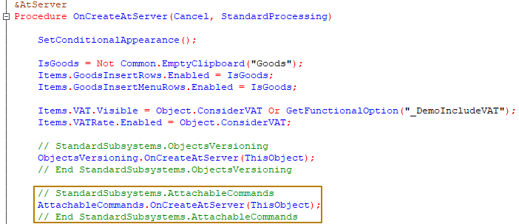
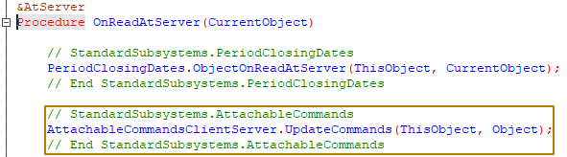
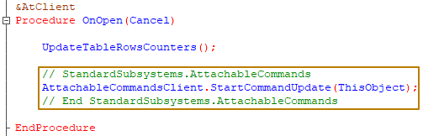
as well as individual procedures and functions inside the comments
// StandardSubsystems.AttachableCommands
…
// End StandardSubsystems.AttachableCommands
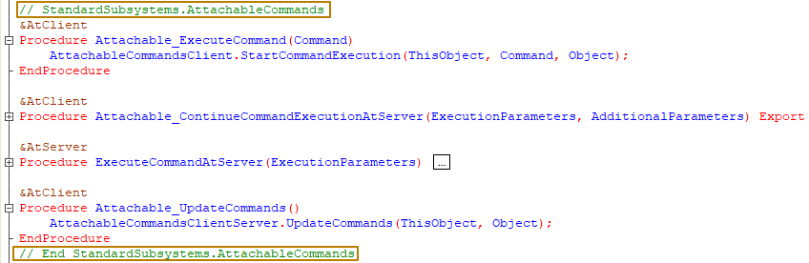
To call print commands from the list form, you also need to connect the form to the AttachableCommands subsystem in the list form module.
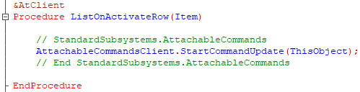
Next, I will need to create templates for print forms. I don't want to waste time on this, so I will use the Print wizard and make simple templates with minor differences. However, the wizard creates a command and a procedure in the manager module, we don't need the commands, so I delete them, and as for the procedures, I delete the procedure for the "Goods receipt" command, and leave the procedure for the "Receipt at warehouse" command to demonstrate different types of handlers.
Print command handlers
There are several ways to process print commands that must be defined at the stage of adding these commands:
- Do not specify either a handler or a print manager. Then it is expected that the object manager module contains the export procedure Print(ObjectArray, PrintParameters, PrintFormCollection, PrintObjects, OutputParameters), in which further processing takes place.

- Specify the print handler in the print command Handler property. This is a client command handler to which control must be transferred instead of the standard Print command handler. It is used, for example, when a print form is generated on the client.
The <CommonModuleName>.<FunctionName> format is used when the procedure is placed in a common module.
The <FunctionName> format is used when the procedure is placed in the module of the main report or data processor form specified in the PrintManager property (see the next paragraph). It should be noted that the handler is called using the Eval() method, so only a function can act as a handler. In this case, the return value of the function is not used by the subsystem in any way. The function must contain one mandatory parameter, PrintParameters, to which a Structure with the following properties is passed:
* PrintObjects - Array - Array of links to selected objects.
* Form - ClientApplicationForm - Form from which the print command was called.
* AdditionalParameters - Structure - Additional print parameters.
- Specify the object name in the PrintManager property of the print command, in the manager module of which the Print procedure is located, which generates spreadsheet documents for this command.
For example:
PrintCommand.PrintManager = "DataProcessor.PrintPaymentInvoice";
In addition, there is the ability to automatically fill in the template without creating any method for these purposes - this is by specifying the common module "PrintManagement" as the print manager. In this case, the command processing and filling of the spreadsheet document according to the template will be performed in the Print procedure of this common module. There are 2 additional conditions when using this print manager:
1) in the print command ID property, you need to specify the full path to the template, for example:
PrintCommand.Id = "Document._DemoGoodsReceipt.PF_MXL_GoodsReceipt";
2) in the template all parameters to be filled in must be specified in square brackets (and, as a result, cannot be located in cells with the "Parameter" filling property)
- A combined method, when the ID property specifies the same or different print forms for print sets, separated by commas, and alternative print managers can also be specified instead of the main one specified in the PrintManager property. For example, if you specify
PrintCommand.Id = "SalesInvoice,DataProcessor.PrintPaymentInvoice.PaymentInvoice"
then the "PaymentInvoice" print form will be generated in the print manager DataProcessor.PrintPaymentInvoice, and "SalesInvoice" in the object specified in the PrintManager property (for example, in the PrintSalesInvoice data processor), and if it is not specified, then in the manager module of the object itself, for which the print command is added.
Important: if the PrintManagement common module is specified as the PrintManager, then no other print managers can be used; all print forms will be generated only in this common module. Accordingly, in the Id field in this case, you can only specify full paths to templates, but not the names of alternative print managers, as in the example above.
Incorrect:
PrintCommand.Id = "Document._DemoGoodsReceipt.PF_MXL_GoodsReceipt,DataProcessor.PrintInvoicesFromSupplier.InvoiceFromSupplier";
PrintCommand.PrintManager = "PrintManagement";
Correct:
PrintCommand.Id = "Document._DemoGoodsReceipt.PF_MXL_GoodsReceipt,Document._GoodsReceipt.PF_MXL_InvoiceFromSupplier";
PrintCommand.PrintManager = "PrintManagement";
Since I previously left the procedure for filling the template of the print form "Receipt at warehouse", I will not specify either a handler or a print manager for this command, but will create an export procedure Print and show how to process the command in the object itself. And I will provide the second print form to be filled in by the print manager, which will be the PrintManagement common module.
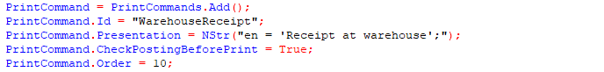
I will start with the handler of the command "Receipt at warehouse" and create the Print procedure in the manager module of the document "_DemoGoodsReceipt". Usually, the processing of the print command in the Print procedure looks like this in a simple form:
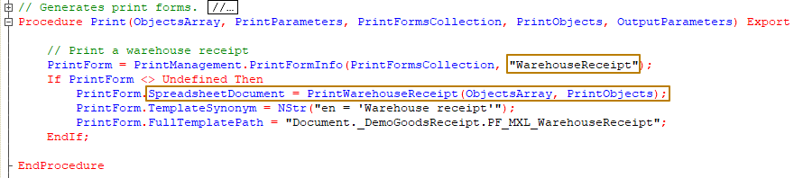
It is better to change the procedure for filling out a spreadsheet document automatically created by the print wizard to a function, as I already did in the lesson on printed forms. At a minimum, such a function must accept two parameters:
- ObjectsArray - an array of references to objects to be printed
- PrintObjects - a list of values, where each value is the name of the area of the spreadsheet document in which the object was printed
Accordingly, after changing it to a function, it needs to be at least slightly modified. First, you need to create a spreadsheet document, and in the end, the function should return this spreadsheet document
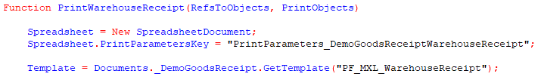
Data should be selected for the array of links to printable objects passed to the function
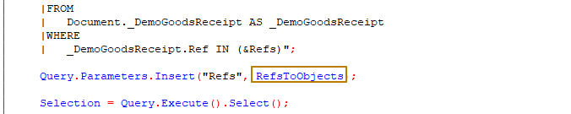
Well, for each document, you need to specify the area it occupies in the PrintObjects parameter:
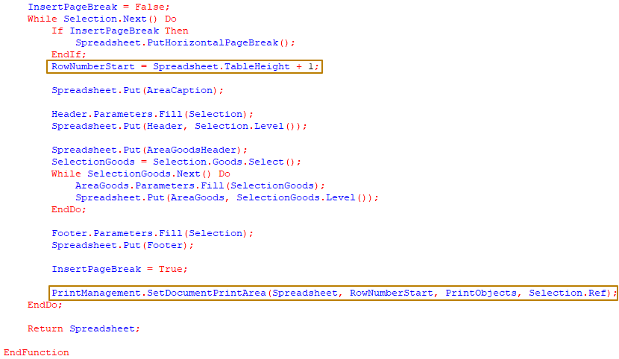
At this stage, you can already try to execute this print command:
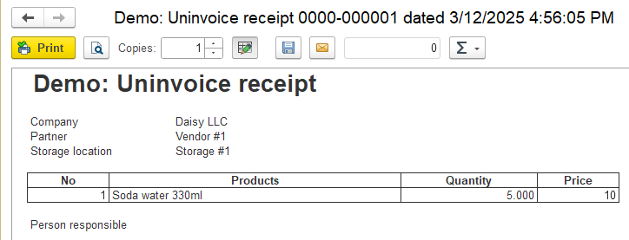
The print form with the handler located in the manager module works. Let's move on to the print form with the PrintManagement print manager, i.e. this is a print form for which the developer does not create code for filling in the spreadsheet document at all.
I remind you that in this case, you need to specify the full path to the print form template in the Id property:
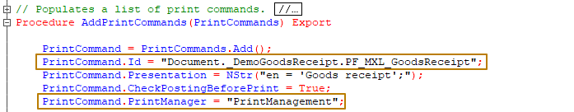
I slightly changed the template so that the document number and date are displayed in the title of the print form:
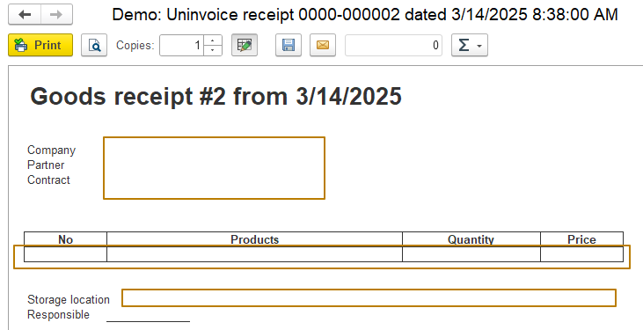
The print form is generated, but of all the parameters, only the date and number in the form title are filled in. This is because the other parameters in the template are not enclosed in square brackets:
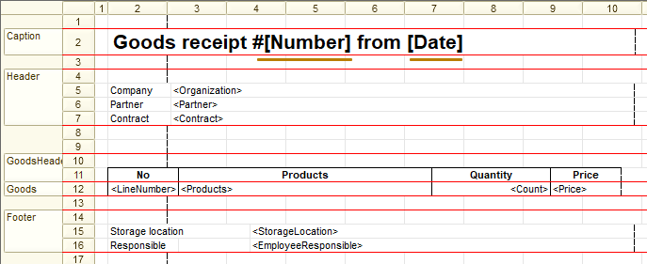
I select all the cells with parameters and change the value of their "FillType" property from "Parameter" to "Template" (you can also select the "Text" value, since the search for fillable parameters in the print manager is performed by checking the text of each cell, but it is better to use the Template in case you need to use your own filling of the print form in the future), after which I enclose each parameter in square brackets. In this case, the parameters of the tabular section must be filled in as follows: [TabularSectionName.ParameterName], for example "[Goods.Price]"
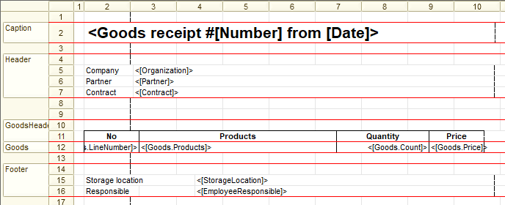
Now the printed form is filled in correctly:
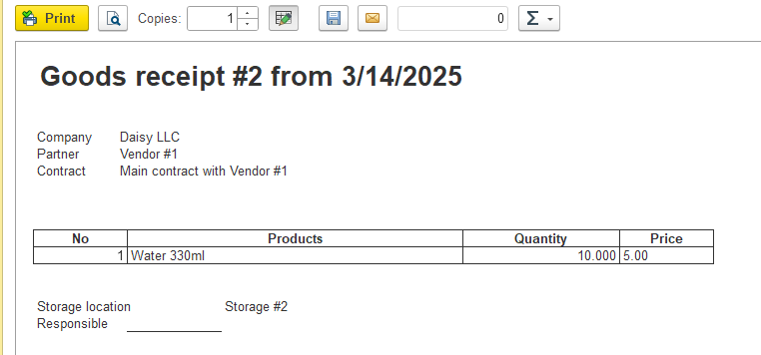
Document set
Let's look at a combined method of processing print commands, which is often used to print sets of documents (some documents often need to be printed together, for example, a "Certificate of work completion" + "Invoice"). As stated above, this method does not allow combining the PrintManagement print manager with any other print managers.
To demonstrate the use of several print managers at once, I will create 3 new templates in which I will fill in and output to a spreadsheet document only the title, as well as 2 data processors, the first of which will fill in print form 1, and the second will fill in print forms 2 and 3:
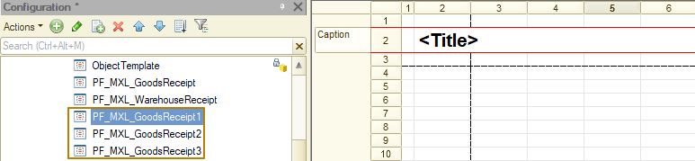
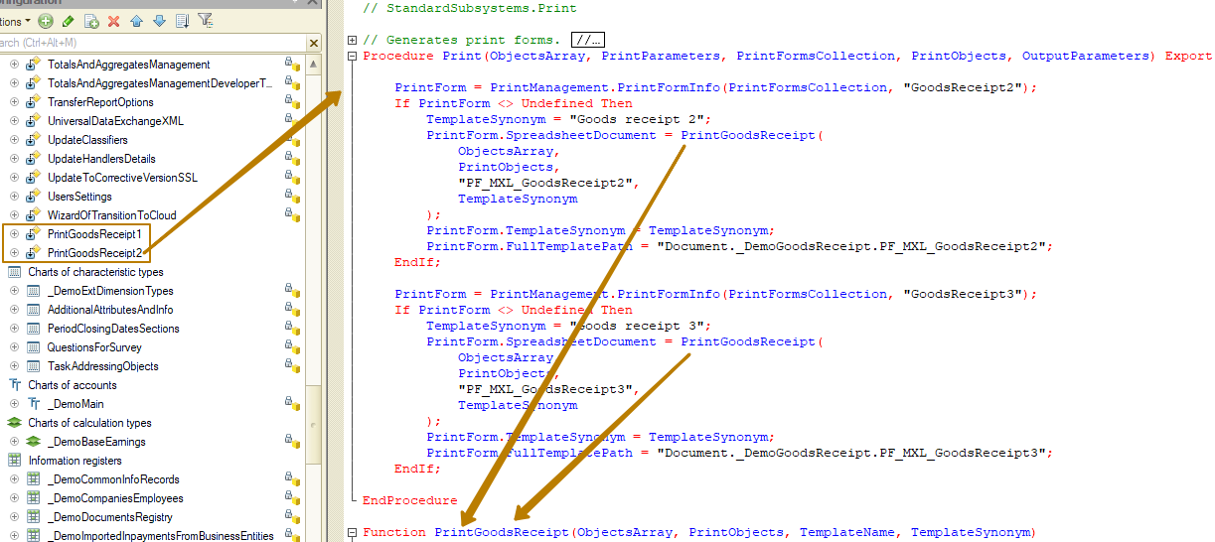
Next, I create a print command in which I specify 4 print forms as identifiers: one is generated in the manager module of the object itself, the second in the data processor 1 manager manager, and the other two in the data processor 2 manager module. I can specify data processor PringGoodsReceipt2 as the print manager, because it acts as a print manager for the largest number of print forms from the set, but then I have to specify the "WarehouseReceipt" print form with the full path to the document manager:
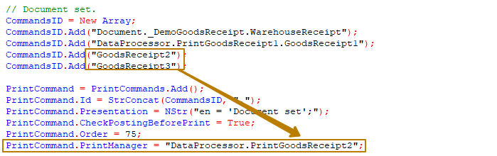
Or I can leave only the ID of this print form, but then I need to specify the print manager for all other print forms, but the PrintManager property can be left blank in this case:
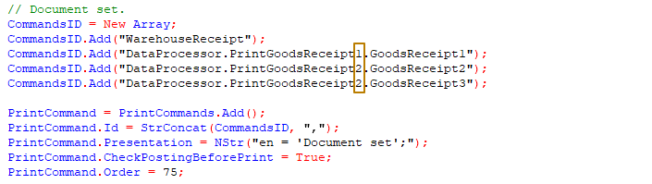
In order for several copies of any printed form to be output to the set, it is necessary to specify it in the ID property as many times as copies are required.
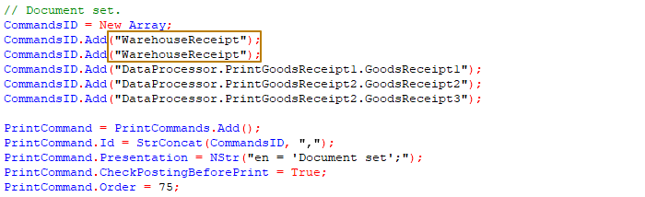
Let's check if the print set works:
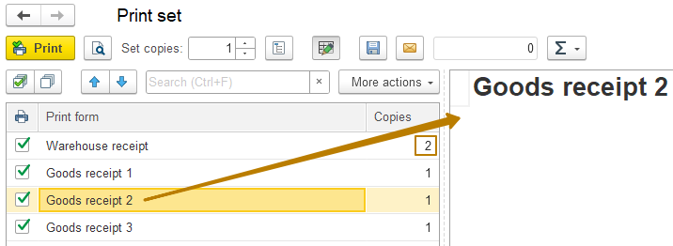

When forming sets of print forms, you can use the "FixedSet" property to regulate the ability of the user to exclude print forms from the set. The default value is False, in this case the user can change the number of copies of each of the print forms, and can also include or exclude forms from the set when printing:
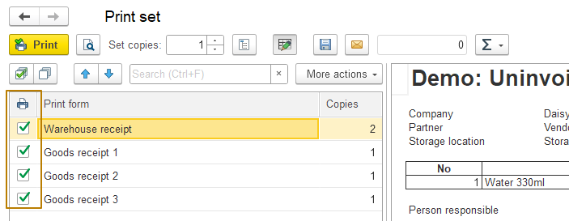
If the value set to True, the user cannot change the composition of the print set:
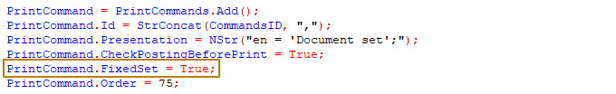
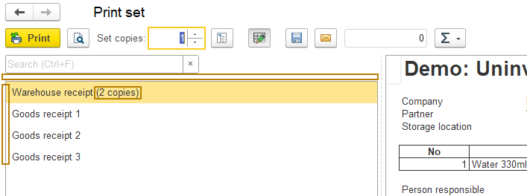
Creating and modifying templates
From the print form, you can edit the template with saving it in the information base or go to the list of all templates in the database:
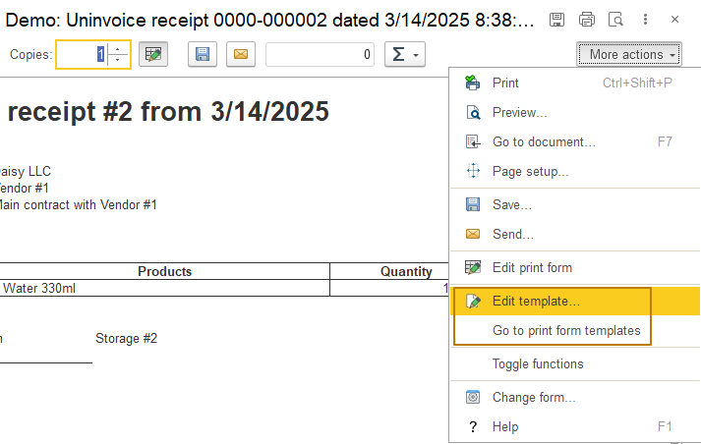
Let's see how the process of editing templates and using them as a replacement for built-in templates for printing looks like. I select the print form "Goods receipt 1", then click the "Edit template" button and in the window that opens, I change the FillType of the Title cell to "Template", I put the header in square brackets, and after the "[Title]" I add the text "(user’s template)" so that the difference is presented simply and clearly.
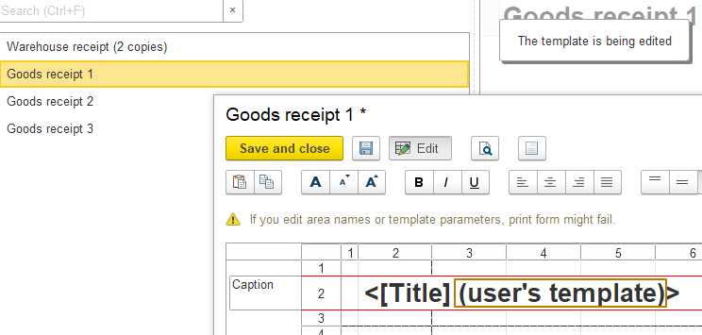
Then I save and close the template, the print form is automatically re-formed, but there is no difference, it is still a template built into the configuration.
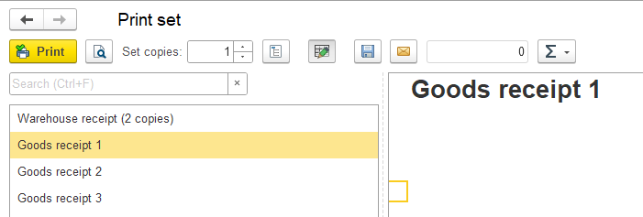
Now I move on to the print form templates ("Go to print form templates" button) to demonstrate how to determine which template is used for printing, how to return to using the built-in template and how to delete the custom template from the database.
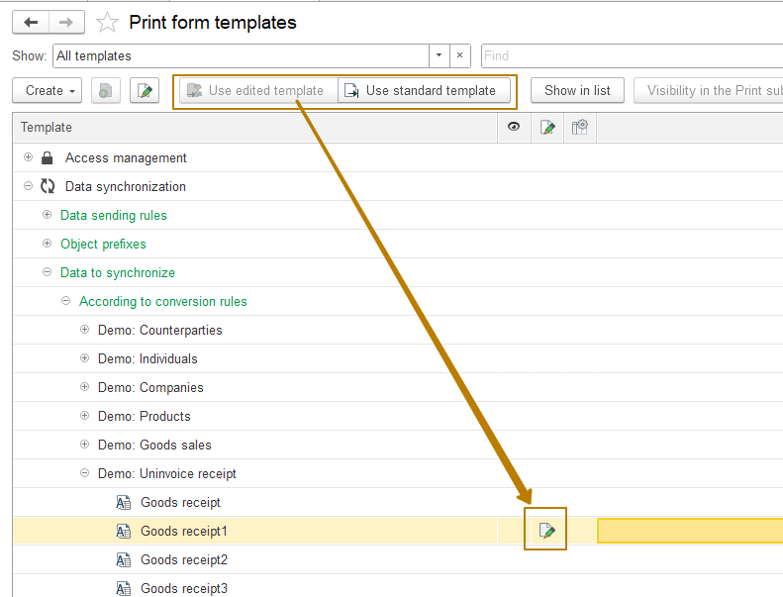
In this image, you can see that in the row with the template "Goods receipt 1" there is an icon with a green pencil on the background of the sheet, and at the top of the panel there are 2 buttons: "Use edited template", which is unavailable and "Use standard template", which is available. They allow you to make the user-modified template or the one built into the configuration the main one.
If the configuration has a modified template, but the standard one is used, then the icon will look like black and white:
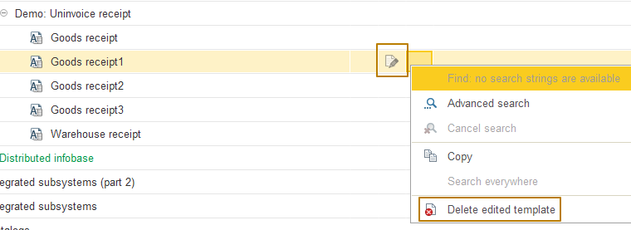
In this case, the modified template can be deleted at any time from the context menu or the "More" submenu, then there will be no icons in the column.
But why in my case the modified template is not used, given that the setting for its use is selected in the list of templates? The fact is that in order for the template marked as the main one in the information base to be used when building a print form, it is necessary to get the template in the code using the PrintManagement.PrintFormTemplate method from the subsystem, and not the GetTemplate method built into the platform. This means that I need to correct the call to the built-in method in all my print forms:
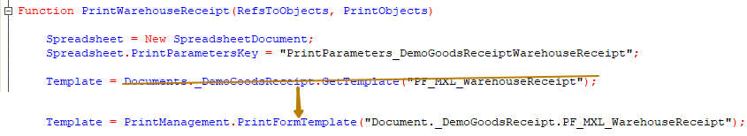
I update the configuration and check the print again. This time, the modified template was used for the "Goods receipt 1" print form:
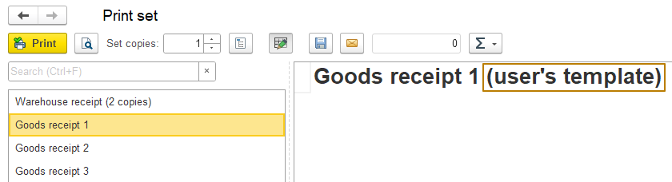
The list of templates can also be opened from the menu "Administration - Print forms, reports and data processors" - this is the hyperlink "Print form templates":
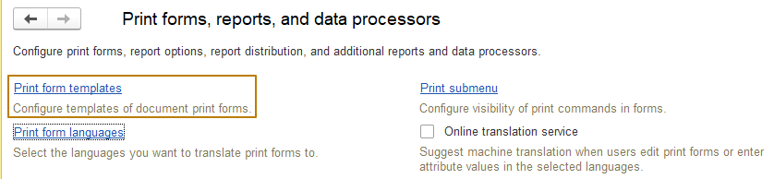
In addition to changing the built-in configuration templates, you can also create new templates/print commands that will be generated using the print manager PrintManagement, which means that the user can independently create print forms without the developer's participation:
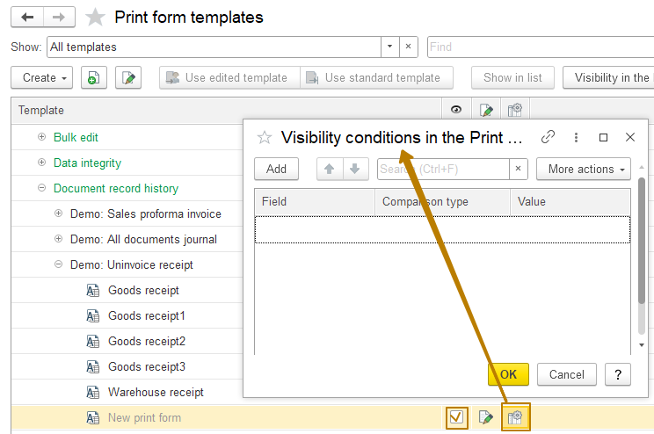
After creation, you must enable the display flag in the Print submenu (see the flag at the image). If necessary, you can also set the visibility conditions of the command by clicking on the gear icon.
In the form of print forms, reports and data processors, there are also print submenu settings, where you can disable some print commands, for external print forms there is a separate column "External print form" with a hyperlink, which you can use to go to an additional data processor, which supplies this print command:
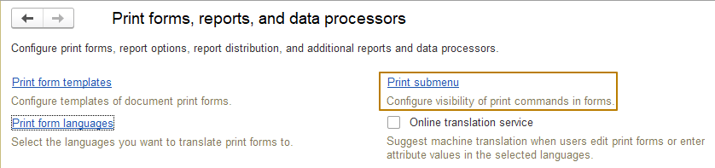
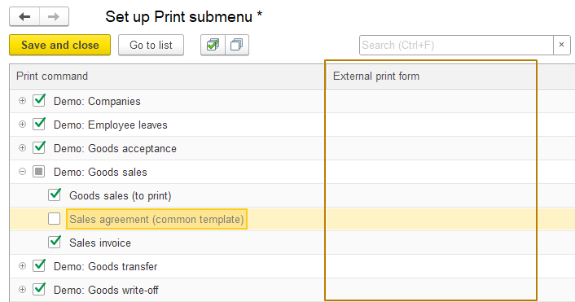
Roles
To configure user access rights to the Print subsystem data, use the roles specified below:
EditPrintFormTemplates - Adding and editing print form templates.
OutputToPrinterFileClipboard (from the "Core" subsystem) - Used to allow output of print forms to the printer and sending them by e-mail.
PrintFormsEdit - Making changes to generated printed forms before sending them directly to the printer or by e-mail, saving them to a file.
